# CS 255 System Design Document Template

## UML Diagrams

### UML Use Case Diagram

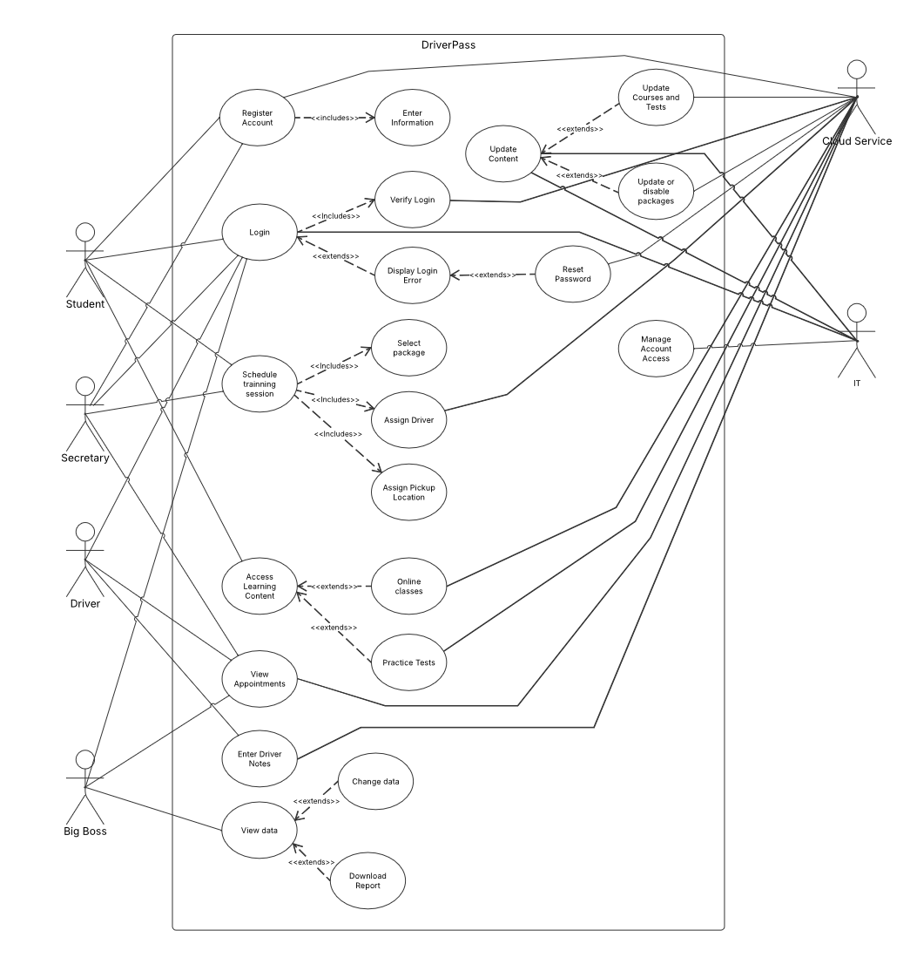

### UML Activity Diagrams

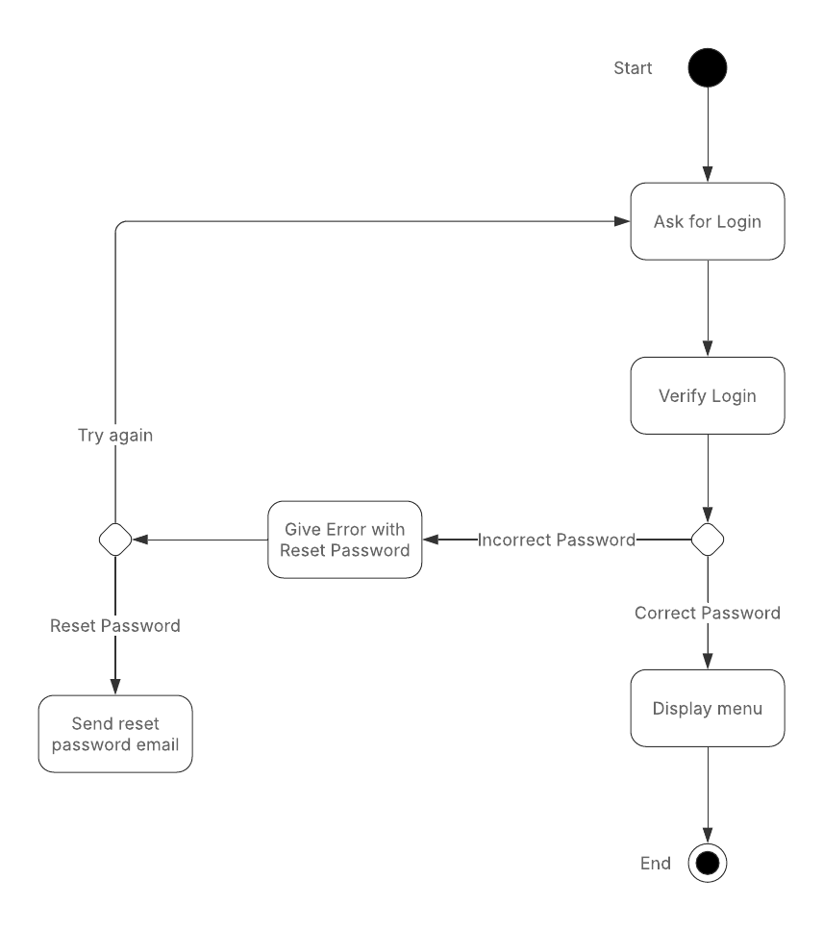

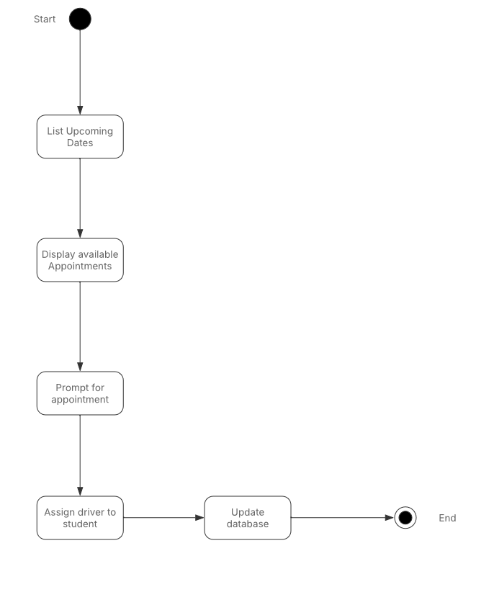

### UML Sequence Diagram

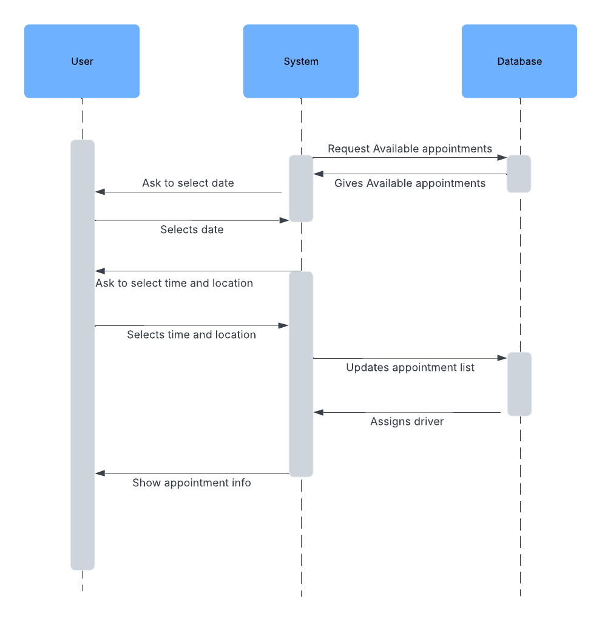

### UML Class Diagram

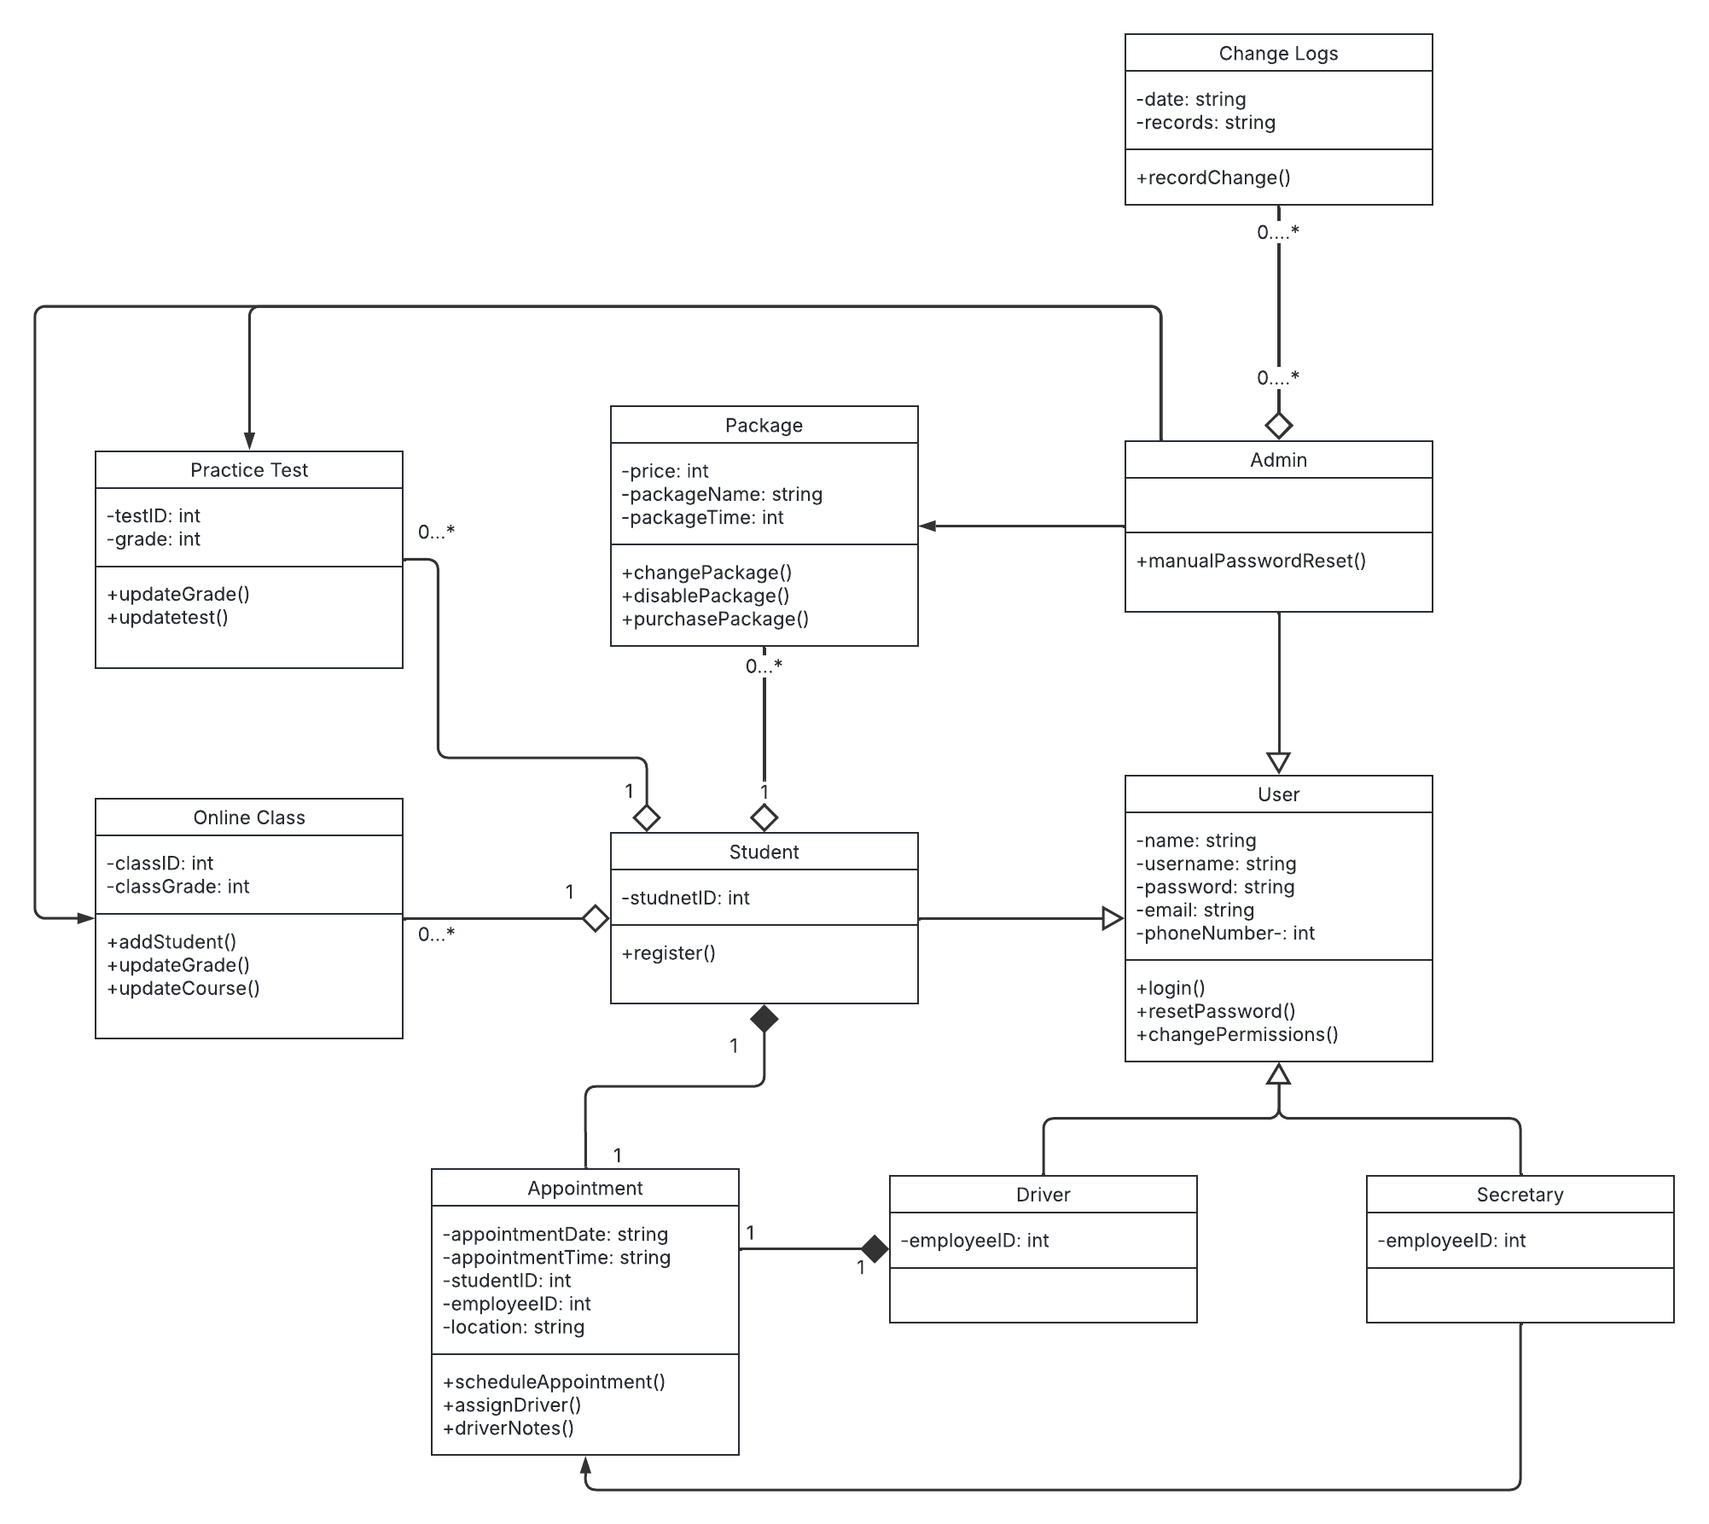

## Technical Requirements

* A web-based client in a cloud environment should run the system
* The system should be updated when needed to keep up with changes to the DMV, content, and prices.
* The system needs to run on desktop platforms like Windows, Linux, and MacOS. The system also needs to support Android OS and iOS to ensure that as many users as possible can access the system.
* Mobile devices can use a browser or a dedicated web app to be more accessible.
* Users will have separate logins with unique emails/usernames and passwords.
* Login information will be case-sensitive.
* An admin should be informed when a user wants to reset their password.
* The system will keep records of changes in the system that the admin can access.
* An admin will be able to reset user passwords and block accounts.
* Specific users will be able to change and disable offered packages.
* Specific users will be able to update the learning content.
* IT admin needs access to the server provided by the cloud service provider and the database.
* Using HTTPS protocol with two factor authentication will ensure a secure connection
* Users will have access to a reset password button that will automatically send an email that will allow them to reset their password.
* The system shall provide users the option to schedule on the road training sessions
* The system shall allow admins to manage account access
* The system shall allow users to view scheduled appointments
* The system shall provide downloadable reports
* The system shall allow users to take practice tests and online classes